Giant Barbershop

WEB Technology Final project

Maksat Kuanysh, SE-2014

Dana Yespenbetova  Astana IT University

Welcome to my website “Giant” Barbershop

Places where only handsome men come out

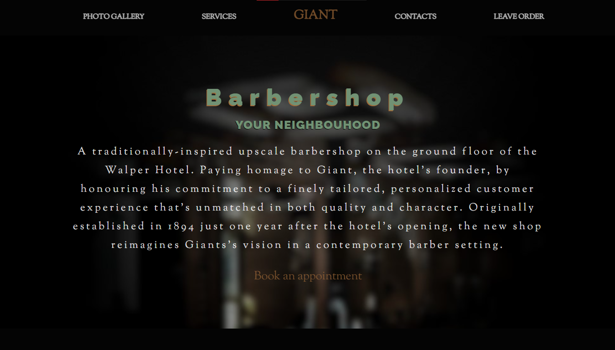

Exclusive and with Story!

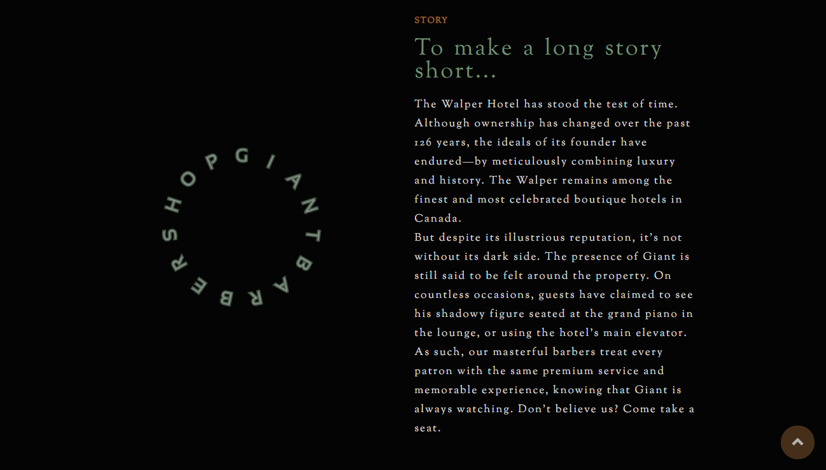

About thousand of good reviews a day

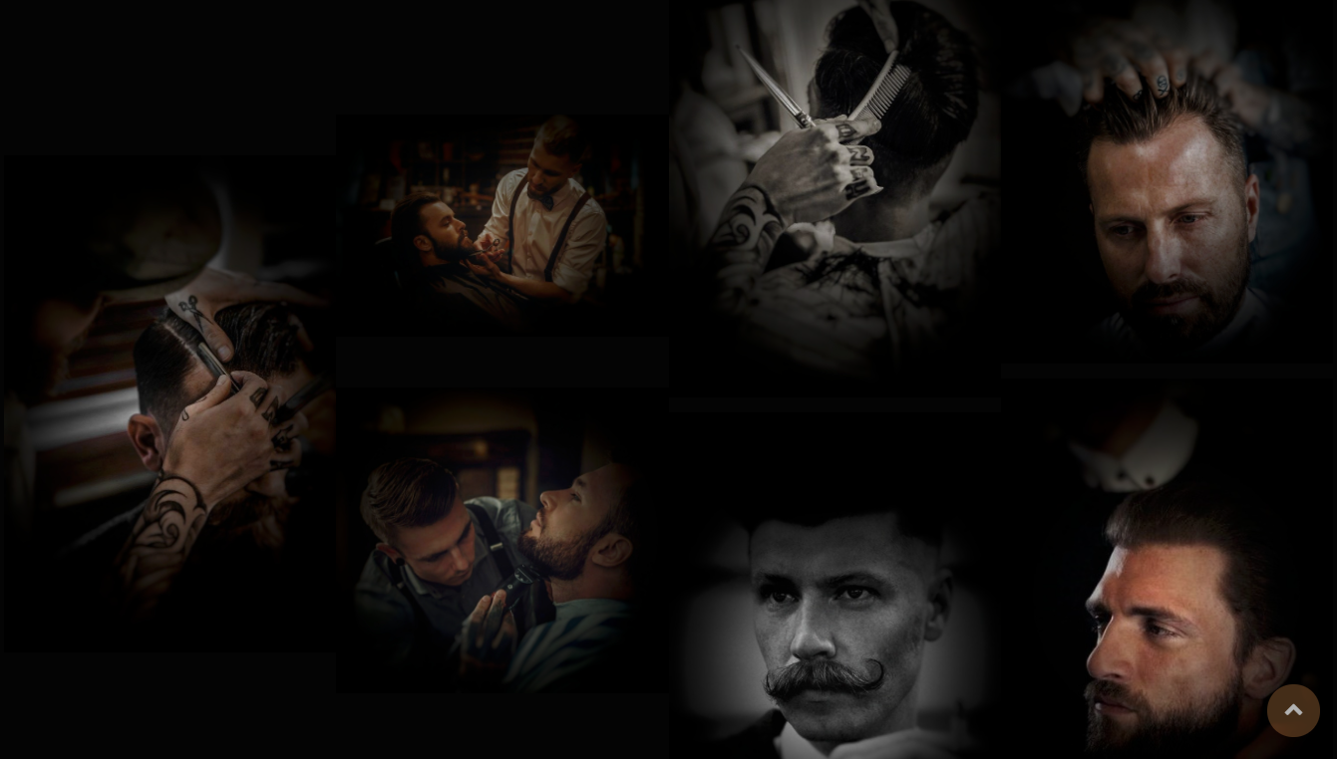

A huge selection of types of haircuts and not only

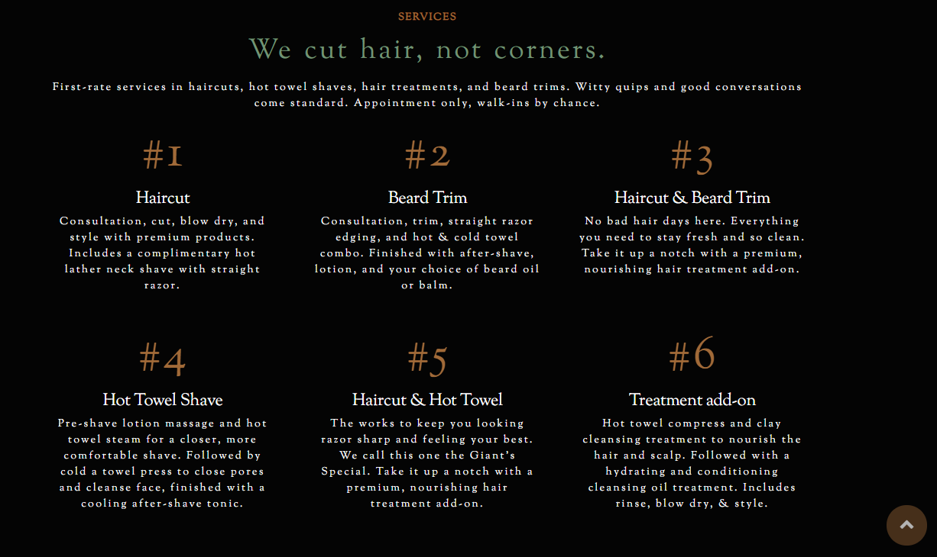

We wait you in Nur-Sultan…

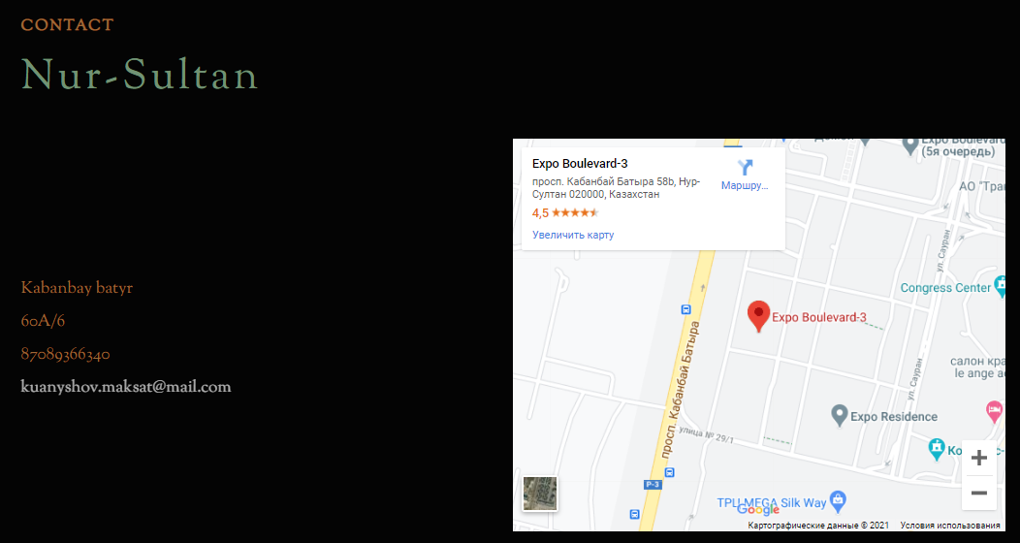

And in Taraz

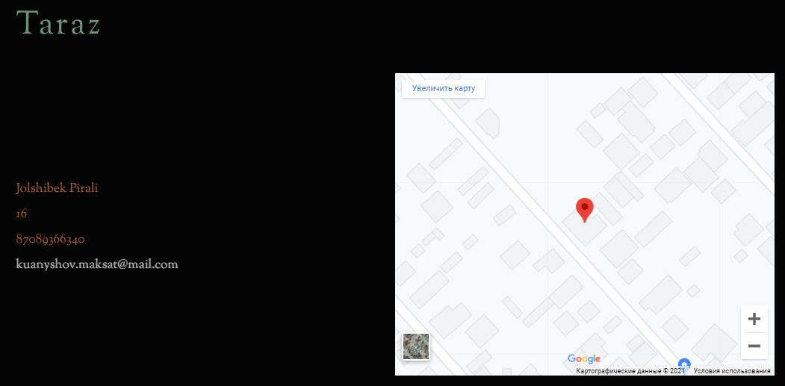

Call us or leave your order online

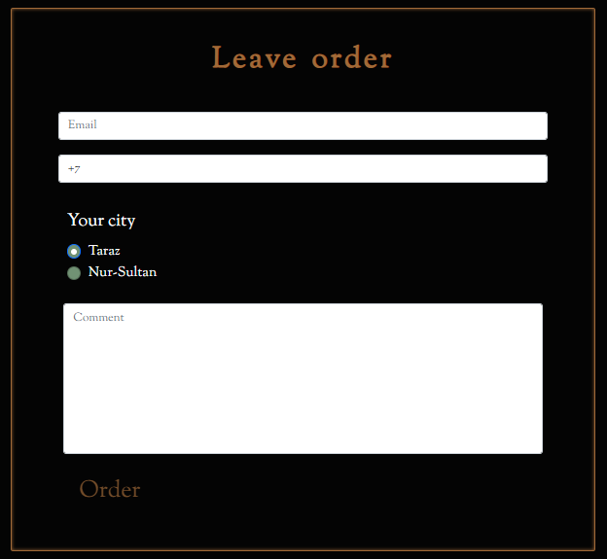

We will be glad for every client

What I used:

* Package folders
* HTML, CSS, JS, JQuery library, SCSS
* Download fonts and links to them too
* Font Awesome
* Bootstrap
* Screen with adaptation
* Icon for website
* Dark design
* About 1200 lines of code

HTML code in brief:

* Header, main (contains 5 parts), footer
* Navbar, offer, story part, photos, services, contacts, form for online register, footer
* h1, h2, h3, h4, p, span,
* Button, images, maps
* Form, input, input button, textarea, radio

CSS (SCSS) code in brief:

* Using em font size
* Displays, flex grids, shadows, justify content,
* Hover effects in CSS, transitions
* Correct usage of properties
* @Font-face
* Pseudo classes :before, :after
* Child subclasses
* Using variables
* Using media screen

JS (JQuery) code, Scroll Reveal expansion in brief:

* On() fuctions and alternatives
* Click, hover functions
* e.preventDefault() functions
* .css pointer
* Sliders for parts of webpage
* Go top button
* “Order” button click animation
* Adding, removing classes
* Media screen and screen width controlling
* .animation() function
* Transitions for animations
* Scroll Reveal delaying

Bootstrap usage in brief:

* Using columns
* Adaptive rows
* Working with forms
* Stylings
* ul, li, a changings

References:

* <https://www.abelsonqueen.com/#hero>
* <https://boardroomsalon.com>
* <https://chivalrygroomingparlour.com>
* <https://maps.google.ru>
* <https://getbootstrap.com/docs/5.0/getting-started/introduction/>
* <https://fontawesome.com>
* <https://jquery.com>